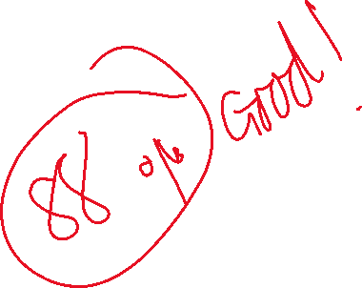

|  |
| --- |
| Lines of code |
| SOEN POE PART 1  Software Engineering |
| |  |  |  | | --- | --- | --- | | Venkata Vikranth Jannatha | 9/27/23 | SOEN6222 | |

**Table Of Contents**

Introduction 2

Functional Requirements for Tree-Saving Program: 2

1. Tree-Establishing Management System 2

2. Communication and Commitment System 2

3. Donation Management System 2

4. Volunteer Management System 2

5. Event Management System 2

6. Fundraising Effort System 2

7. Financial Revealing System 2

8. Impact Evaluation System 2

9. Supporter Commitment System 3

10. Website Management System 3

11. Data Analysis System 3

12. Customer Relationship Management (CRM) System 3

13. Web-based Social Media System 3

These are the External Requirement for the Tree-Saving Program: 3

Climate Programming interface Point of interaction 3

The Non-Functional requirements for Tree-Saving Program 4

References 5

# Introduction

The purpose of the project in view of case study is to make a website for a non-profit organization that is committed to saving trees. The website I am making helps expects to change the way the organization works by giving a stage that will assist them with dealing with their tree-establishing activities, draw in with their supporters and volunteers, and work with gifts. Moreover, the website will act as a helpful tool, educating guests about the significance regarding trees for our current circumstance and natural life, and exhibiting the organization's work and tentative arrangements.



The scope of the project incorporates planning and fostering a website that addresses these issues. The project will follow an 'agile' approach, which includes working closely with the non-profit and end-clients of the website, confirming their input, and making changes all through the improvement interaction. This approach guarantees that the website works well as well as lines up with everybody's necessities. A definitive objective is to convey a website that essentially adds to the non-profit's main goal of saving trees.



# Functional Requirements for Tree-Saving Program:

According to (Shvetsova, 2023) , The Functional Requirements includes with practical explanation.

1. Tree-Establishing Management System: A system that takes information about tree planting activities from staff and volunteers, processes it, and generates progress reports for review.
2. Communication and Commitment System: A system that conveys correspondences (messages, refreshes, warnings) made by staff to allies and volunteers, bringing about expanded commitment.
3. Donation Management System: A system that manages the collection and tracking of donations from supporters.
4. Volunteer Management System: A system that oversees volunteer recruits, timetables, and errand tasks.

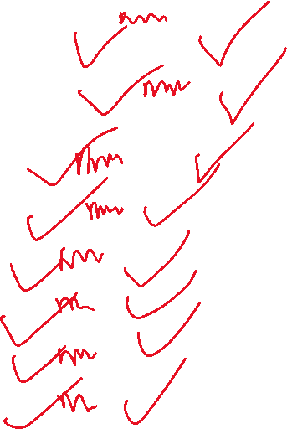

1. Event Management System: A system that handles the preparation, booking, and execution of occasions.
2. Fundraising Effort System: A system that deals with the creation, execution, and tracking of fundraising campaigns.
3. Financial Revealing System: A system that tracks all financial transactions and generates financial reports.
4. Impact Evaluation System: A system that surveys and reports on the effect of the association's exercises.
5. Supporter Commitment System: A system that tracks supporter engagement and provides insights to improve engagement strategies.
6. Website Management System: A system that deals with organization’s website content and user interactions.
7. Data Analysis System: A system that analyses various data to provide insights for decision-making.



1. Customer Relationship Management (CRM) System: A system that manages the organization’s relationships and interactions with supporters and volunteers.
2. Web-based Social Media System: A system that incorporates with virtual entertainment stages to advance the association's exercises and missions.

These requirements are testable on the grounds that they can be checked by utilizing different strategies like review, exhibit, examination, or testing. For instance, to check if the online donation system works, we can try making a pretend payment. If the payment goes through and is recorded correctly, then it works! Similarly, to check if the tree monitoring system works, we can see if the sensors and GPS devices are working right and sending correct data to the website.

These requirements are feasible on the grounds that they can be executed utilizing existing advancements and assets. For example, if we need a system for online donations, we can use services like Zapper or PayPal to handle the payments.

These requirements are clear since they are expressed in basic and exact language, without equivocalness or uncertainty. They likewise indicate the normal way of behaving and result of the framework, without including unnecessary details or plan choices.

# These are the External Requirement for the Tree-Saving Program:

Climate Programming interface Point of interaction: The website should communicate with a climate Programming interface to get and show the current and estimated weather patterns for the tree-planting areas. This would include sending appeal to the Programming interface with the area arranges, getting JSON reactions with the climate information, and parsing and introducing the information on the website. This point of interaction would help the organization plan and screen the tree-planting exercises and illuminate the allies and volunteers about the weather patterns. This must relate to functional requirement 3: "The website will enable volunteers to pursue tree-establishing occasions and view their timetables and areas".

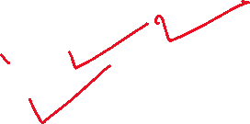

The Non-Functional requirements for Tree-Saving Program: These are the non-functional requirements for my case study based on (Sommerville, 2016, pp. 172-173)

- Usability: The website must be easy to understand, natural, and simple to explore. It ought to give clear directions, input, and help highlights for the clients. It should likewise follow the standards of good UI and UX design.

- Performance: The website must be responsive, quick, and dependable. It needs to stack rapidly and handle numerous solicitations without postponements or blunders. It must also have a high accessibility and uptime.

- Security: The website must safeguard the information and protection of the clients, allies, volunteers, and benefactors. It ought to utilize encryption, confirmation, approval, and other security measures to project unapproved access, correction, or exposure of information. It must likewise follow significant regulations and guidelines regarding information security.



- Scalability: The website must have the option to deal with expanding measures of information and clients as the organization develops. It ought to have an adaptable and measured design that considers simple extension and change of elements and capabilities. It has to likewise apply cloud-based administrations and assets to improve performance and cost.

- Maintainability: The website must be not difficult to keep up with, update, and troubleshoot. It ought to keep coding guidelines and best practices, apply fitting documentation and remarks, and have a variant control framework. It ought to likewise have a testing structure and instruments to guarantee the quality and functionality of the product.

# References

Shvetsova, Y., 2023. *Functional and non-functional requirements of online shopping system: List & examples.* [Online]   
Available at: https://elogic.co/blog/functional-and-non-functional-requirements-for-ecommerce-websites/  
[Accessed 25 September 2023].

Sommerville, I., 2016. *Software Engineering.* 10th ed. Hallbergmoos/Germany: Pearson.

